#SaferToBeMe 2025
Overall, how would you rate the event that you attended?
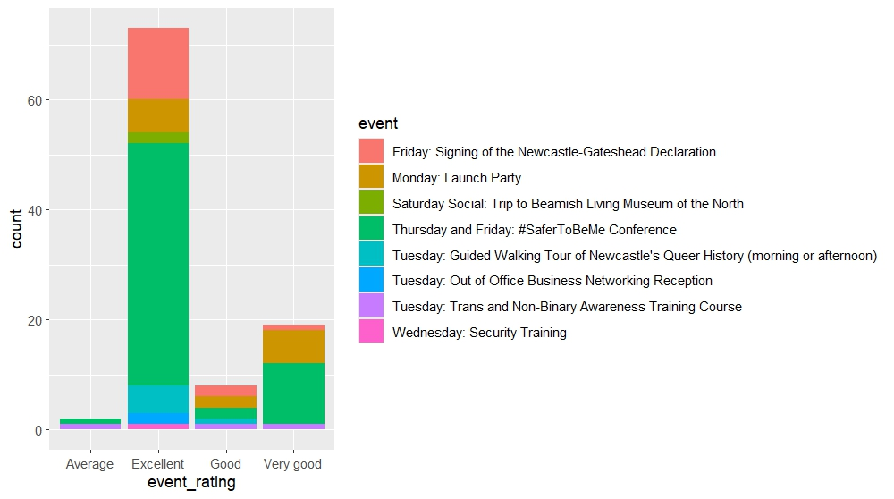

How well organised was this event?

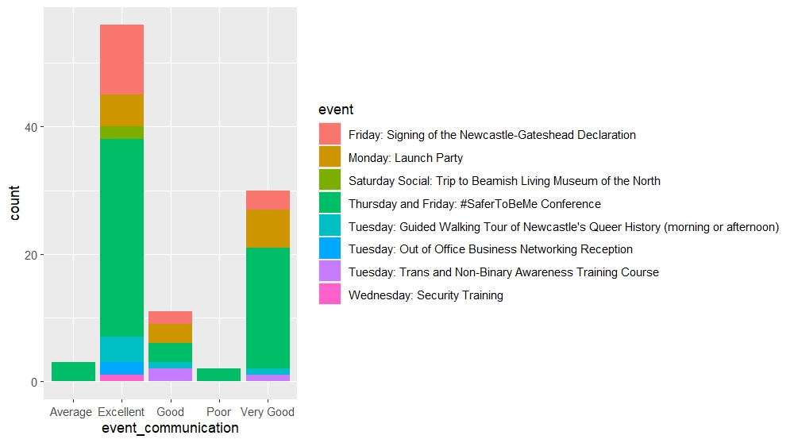

How well did we communicate this event to you?
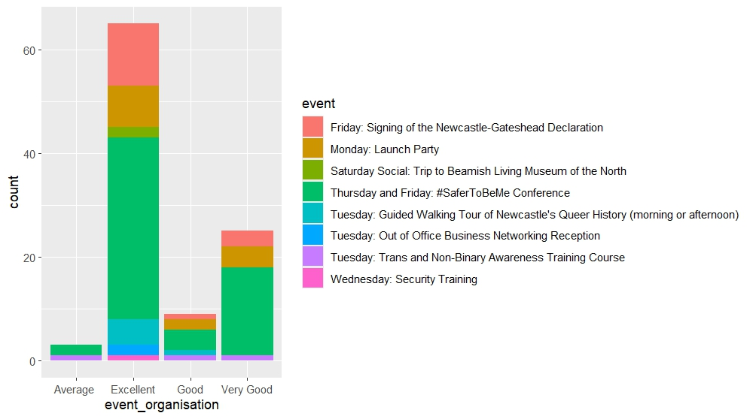S

#SaferToBeMe2023
Overall, how would you rate the event that you attended?
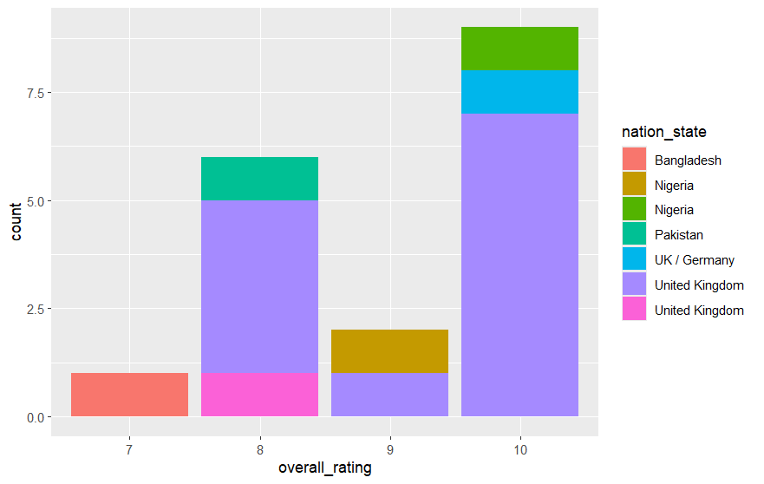

How useful was the information leading up to the event you attended?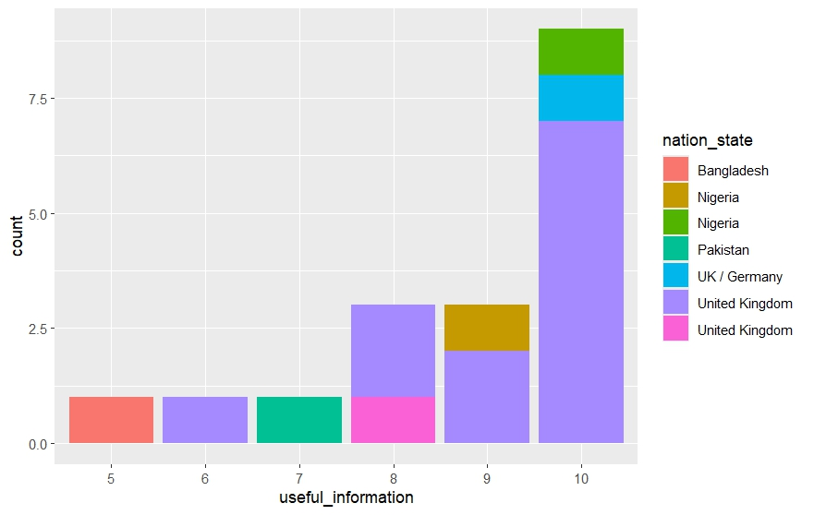

I found #SaferToBeMe to be an friendly and welcoming event: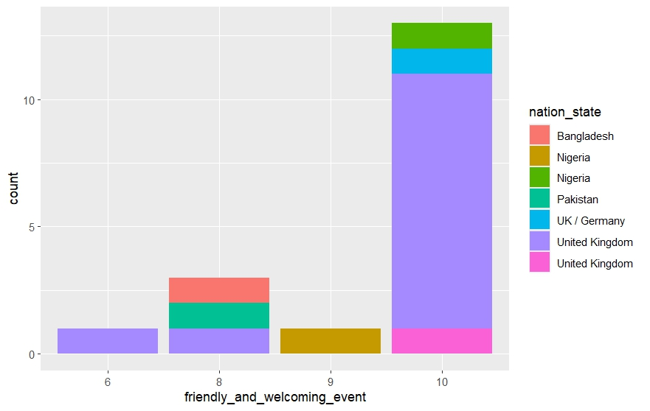

I found the buildings used for #SaferToBeMe to be suitable and inclusive buildings
I found the buildings used for #SaferToBeMe to be suitable and inclusive buildings
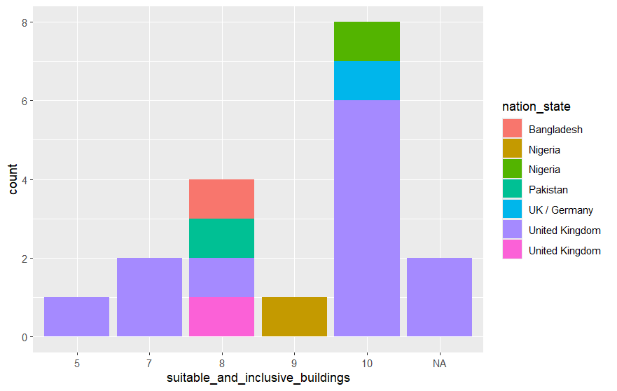

I found #SaferToBeMe to be an interesting and varied event overall: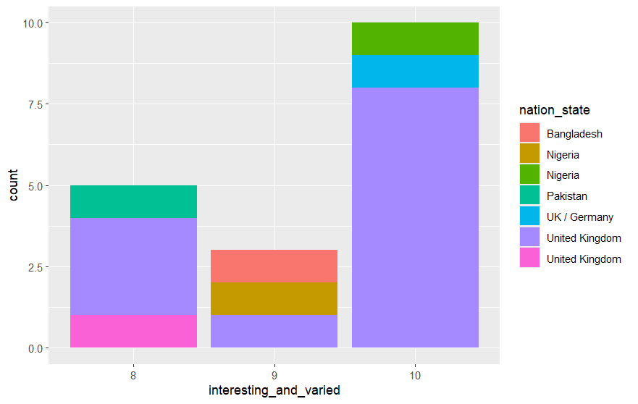

Overall, and if I have to rate my overall experience of everything, I found #SaferToBeMe to be:

Would you like to see another #SaferToBeMe?